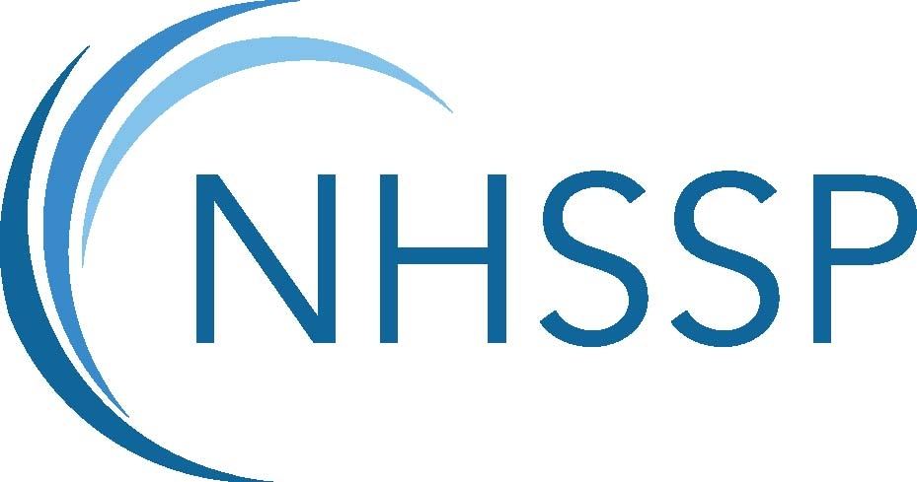 | 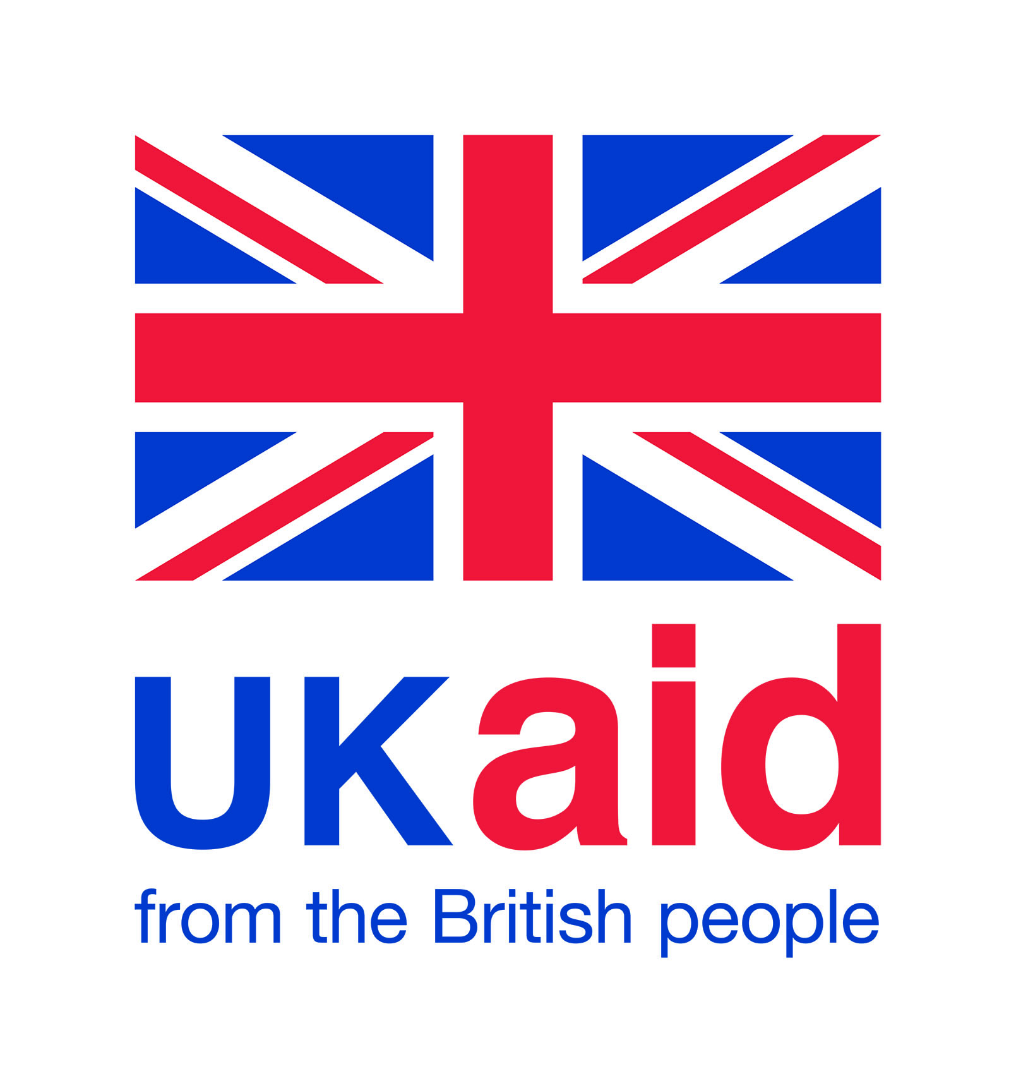

Job description
Job title | Pharmacist
Thematic Area | Leadership and Governance (L&G)
Geographic Area focus | All governance spheres (Federal, Provincial & Palika)  Focal provinces: Province 2, Province 5, Province 7
Reporting and Accountability to | L&G Thematic Team Lead
Technical Co-ordination with | International Technical Specialist
Technical and Line management responsibility for | TBC
Liaison with | NHSSP Strategic Adviser (Financial Management), Public Financial Management Advisor/Specialist, Governance Advisor Specialist
Location | Kathmandu, Nepal
Type of contract | 1 year , full-time contract, 40 hours per week
Post holder | To be recruited
Background
The Nepal Health Sector Support Programme 3 (NHSSP3), funded with UK aid, runs from March 2017 to December 2020, with an extension to December 2022 recently confirmed. We seek to build a resilient health system that delivers quality health services, ensuring that no-one is left behind. The programme is led by Options Consultancy Services Limited with two consortium partners: HERD International and Oxford Policy Management. For further details on each consortium partner – please see respective websites: Options: www.options.co.uk ; HERD International: https://herdint.com/; OPM: https://www.opml.co.uk/
The programme has two components. The first component is the provision of responsive and technical support to the Ministry of Health and Population (MoHP), increasing its capacity to improve health policy-making and planning, procurement and financial management, health services and the use of evidence for planning and management. The second component aims to increase the MoHP’s capacity to retrofit health infrastructure to withstand future earthquakes. Both components are integrated and provided by a team based in Kathmandu and “embedded” with the Government of Nepal.
The two-year costed extension to the programme is in response to federalism and will transition technical assistance from the Federal MoHP to local level governments in priority provinces and municipalities. We have reconfigured our technical assistance into three thematic areas which align with new subnational governments overarching priorities for strengthening health outcomes: leadership and governance resulting in improved stewardship of the health sector; data for decision making, facilitating the use of high quality data to enable decision making; and coverage and quality, institutionalising sustainable quality assurance and improvement processes with access to quality basic healthcare services. Cutting across and supporting the three thematic areas is health infrastructure retrofitting priority hospitals, sub-national support to produce integrated health infrastructure development plans and capacity enhancement and policy development. Gender, Equity and Social Inclusion (GESI) will cut across all areas and will be integrated into the design.
Main purpose of the Job
The Pharmacist will provide TA under the Leadership and Governance Thematic Area. The aim of this thematic area is to provide effective technical inputs to the MoHP/DoHS to enable them to deliver against the objectives of NHSP 3, especially policy performance improved through better formulated and implemented policies across the spheres, with governance functions carried out efficiently, effectively, equitably and in a responsive manner.

The main responsibility of the Pharmacist is to build the technical capacities within the Management Division/Logistics Management Section of the MoHP, and provincial & local procurement entities to establish/strengthen procurement processes for pharmaceutical and non-pharmaceutical goods and services; ensure that these comply with the procedures of the Public Procurement Act and Regulations of Nepal and of other relevant regulatory authorities; and aim to make processes transparent and duty-bearers accountable.

Main duties
Specific technical delivery responsibilities
- Lead on the support to government agencies in strengthening Consolidated Annual Procurement Plan (CAPP), eCAPP, eTSB, logistics management functions, and their systematic use.
- Lead on the support to government agencies to enhance their capacity in procurement and logistics management through strategic engagement in procurement processes
- Lead on the support to MD/LMS to revise the Technical Specifications of essential medicines, vaccines, contraceptives and surgical goods and equipment; and support updates to the Technical Specification Bank (TSB) of DoHS-MD/LMS to ensure high quality medicines and equipment are procured.
- Lead on the technical support in preparing the Standard Operating Procedures (SOPs)/Guidelines for pre-shipment inspection (PSI) and post-delivery inspection (PDI) of pharmaceutical and non-pharmaceutical surgical goods under contract (pharmaceuticals, vaccines, family planning, reproductive health commodities, and medical equipment).
- Support the preparation and systematic use of the above SOPs and guidelines (and any other relevant ones) at all levels of governments' procuring entities; provide planning support, and formal training on the implementation of the SOPs.
- Provide technical support on developing sampling parameters, sampling protocols and methodologies for laboratory testing of any items.
- Lead on developing the quality assurance plan (QAP) and support the MD/LMS to regularly use it for procurement and supply chain of pharmaceutical products.
- Ensure provision of technical assistance for the capacity building for of personnel working on procurement quality assurance at federal, provincial and local government levels.
- Support MoHP/DoHS to undertake a periodic rapid market survey on drugs, an assessment of quality of medicines, and an assessment of the use of information systems including LMIS; and support the strengthening of the procurement chain.
- Support the MoHP/DoHS to undertake an indepth review and assessment of the drug procurement practices, identify any bottlenecks and solutions to strengthen the system, and provide tailored technical support to the relevant government departments to chart out a roadmap to implement any recommendations arising from the review.
- In collaboration with other EDPs, support the MoHP/DoHS to undertake a review of the essential medicines supply chain (particularly MNH related) to identify root causes for stock-outs at facility level and identity ways in which these can be addressed.

Cross-team responsibilities
- Provide substantive inputs to evidence building and knowledge management on essential drugs, procurement and related issues, and share knowledge/information such as policies, health planning and programming, budget profiles, procurement, and health outcomes within NHSSP.
- Provide technical inputs to and support institutionalisation of various programme monitoring mechanisms within the government system related to L&G thematic area.
- Support technical discussions and provide inputs to DoHS/MoHP and draw out implication for sustaining effectively delivery of the BHCS and other NHSSP supported TA programmes, that involve procurement of essential drugs and commodities.
- Encourage and support adoption of bottom-up approaches within the Govt. through mechanisms that strengthen local level planning and enable stronger and effective linkages with higher levels of governance.

Management responsibilities
- Provide line management and technical management oversight (if needed) for the Procurement Advisor and Bio-medical Engineer to ensure high quality TA support on area of procurement of essential medicines and commodities. This will entail ensuring the technical priorities are responsive to sub-national priorities and providing strategic direction to this area to enable effective working and achievement of programme objectives.
- Support the annual technical planning for the L&G thematic area under the leadership of the L&G Thematic Team Leader, and in collaboration with the Lead Provincial Coordinators.
- Lead on writing any technical outputs and deliverables as assigned and collaborate with the Planning Advisor/ Specialist and Governance Advisor/Specialist as required in a timely and proactive manner.
- Identify, monitor and report any risks arising to the programme delivery of L&G thematic area results; and under the leadership of the L&G Thematic Team Lead contribute to managing and addressing risks.

One-team approach, Collaborations and Relationships
- The Pharmacist will adopt an “one team approach” to delivery of the programme, and consistently work towards achieve the cross cutting objectives of building the resilience and improving the equity and quality of the Nepal health system while Leaving No-One Behind.
- Work collaboratively with all NHSSP members across all thematic areas at federal and sub-national level to ensure consistency and quality of the L&G thematic area’s delivery.
- Work
- Build and manage positive and productive relationships with MoHP/DoHS an on-going basis, and apply supreme diplomacy, influencing and consensus-building skills to build alliances with a range of stakeholders, external development partners and networks.
Note: This job description reflects the present requirements of the post. As duties and responsibilities change and develop, based on contextual changes, the job description will be reviewed and be subject to amendment in consultation with the job holder.

Signed by: | Date:

Criteria | Essential | Desirable
Qualifications
Post-Graduate (Masters' or Professional) degree in Pharmacy
Experience
Minimum 8 - 10 years professional experience in procurement issues with a special focus on health products and pharmaceuticals.
Specific experience in the policy development, procurement, project management of health related products (including preparing technical specifications of medicines, processes, market knowledge, etc.).
Good understanding of pharmaceutical and drug related laws and policies in Nepal and of the regional market.
Knowledge and experience on GMP and quality assurance of pharmaceutical items.
Knowledge of supply chain management
Skills and attributes
Strong leadership skills
Self-starter, able to work independently or as part of a team
Critical thinking and problem solving skills
Excellent planning and organising skills
Ability to make and articulate clear decisions
Strong internal and external communication and facilitation skills
Ability to collaborate and be a team worker
Excellent negotiation abilities
Other requirements
Commitment to equal opportunities

A commitment to the programme’s and NHSSP principles of Safeguarding, Do No Harm, and to comprehensive sexual and reproductive health and rights

Applicants must have the right to live and to work in Nepal

Ability to travel within Nepal as required

Fluency in written and spoken English

